Short-Term Load Forecasting based on Internet of Things (IoT)

Authors Name/s per 1st Affiliation (Author)
line 1 (of Affiliation): dept. name of organization
line 2-name of organization, acronyms acceptable
line 3-City, Country
line 4-e-mail address if desired
Authors Name/s per 2nd Affiliation (Author)
line 1 (of Affiliation): dept. name of organization
line 2-name of organization, acronyms acceptable
line 3-City, Country
line 4-e-mail address if desired

Abstract— In the era of internet every device is getting connected to the internet. Devices that are connected to the internet are called Internet of Things (IoT). In this paper we have assumed that IoT devices can share their power consumption history. Based on data points collected from real world environment we have conducted experiments to show that IoT can used as a reliable backbone of short term load forecasting system. In the experiment four machine learning algorithms Long Short-term Memory (LSTM), Support Vector Machines Regression, Decision Forest Regression with AdaBoost and Nearest Neighbors Regression were used to analyze the performance of the load forecasting system. Result of the experiment have shown that short term load forecasting system based on LSTM will give more reliable result with root mean square error of 1.65
Keywords— IoT, Forecasting, Save electricity.

Introduction (Heading 1)
Electrical energy generation and distribution is a complex and costly process. Efficient grid management plays a big role to reduce the cost of energy production. Grid management comprises of planning for load demand, maintenance of generation units, supply lines and efficient load distribution across the supply line. Therefore an accurate load forecast will increase the efficiency of planning process of a power generation company. Power generation companies do their plan based on data collected manually. Therefore real time prediction is not possible. If data can be collected in real time, forecasting in real time will be possible. Strong and reliable Internet infrastructure are already present. Every device we use in our daily life are gradually getting connected to the internet to facilitate smart home technologies like Google Home [1], Amazon Alexa etc. A device connected to internet usually treated as IoT. In general a device with sensors, microprocessor or microcontroller which can connect to the internet, send and receive information through internet is called Internet of Thing (IoT) [2]. If the devices are configured to send energy uses data to the internet, these data can be used to give real time forecasting. In this paper we have shown that real time load forecasting is possible with the help of IoT and state of the art artificial intelligence algorithm LSTM Network and machine learning algorithms Nearest Neighbors Regression, Support Vector Regression and Decision tree Regression with AdaBoost.
First of all, increased demand of electricity is creating pressure on production companies as well as natural resources. We know natural resources which are used to produce to create electricity are limited in nature. Secondly, the byproduct of electricity generation is pollution. Again, cost for producers and consumers are increasing day by day. Therefore to ensure sustainable development research communities have shown great interest on how to reduce electricity demand by efficient use of electricity. One of the important of methods that is used to facilitate efficient use of electricity is load forecasting [3]. With the help of load forecasting producers can tune their production plan and consumer can optimized their electricity consumption. Existing forecasting system relies on data collected from production and distribution unit. We have shown that with the help of IoT load forecasting can be done in more easy, convenient and reliable way.
IoT can be used as a reliable backbone of a load forecasting system. To support our claim we have tested our system with real world datasets. Based on this dataset we have done empirical comparison and performance evaluation of four machine learning algorithm. This system will help home user to reduce their power consumption by early warning of future power use.*Reference of home management needed here* This will also help the power generation company to meet their demand efficiently by planning ahead of time.
In this paper, section – 2 provides the literature review in brief description including and techniques used in the system. Proposed model including the algorithms and discussed in section - 3. Results and analysis are presented in section - 4. Lastly section - 5 gives the conclusion and future work.

Related Work
First, Load forecasting prediction was done my many others using different algorithms. Kong, W. worked on deep learning based method with appliance behavior learning using LSTM and was compared with the Feed Forward Neural Network (FFNN) and K-nearest neighbors (KNN).
Ghulam and Angelos compared the performance of feed forward deep neural network (FF-DNN) and recurrent neural network (R-DNN) on the basis of accuracy and computational performance in the context of time wise short term forecast of electricity.
Papia Ray, Santanu Sen and A.K. Barisal granted two hybrid methodologies based on DWT in combination with ANN or SVR for short term load forecasting taking into consideration temperature, humidity dew point and load consumed a particular day at particular hour.
Taking in consideration of the above mentioned work we have implemented an IoT based load forecasting system. The core algorithm of the forecasting system is a machine learning algorithm. To select best performing algorithm we have tested performance of several machine learning algorithm with a new dataset called “UK-DALE dataset” [8].

Proposed model
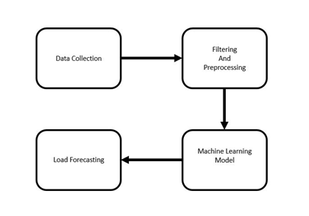Fig. 1. Proposed Model
The IoT based Short Term Load forecasting system is consist of IoT devices and a central processing unit. IoT devices are configured to upload power usage data to the server. The central processing unit is configured to do calculation based on a selected machine learning algorithm. Based on the calculation and learning process the unit will give prediction. In fig-1 the workflow is shown.
Main idea of this paper is to forecast total power consumption based on the data collected from the IoT devices. Due to limitations of time and resources we could not configure devices to upload power uses data to the internet.
To determine which prediction algorithm works best for our model we have implemented four machine learning algorithms and compared them.
In particular, the following numerical forecasting techniques were used:
• Nearest Neighbor Regression: KNN regression is used to calculate average of targeted value of k nearest neighbors. Using inverse distance weighted average of the k nearest neighbors can also be calculated. KNN classification and KNN regression uses the same distance functions.
• Support Vector Regression: Support Vector Machine can also be used as a method of regression, keeping all the fundamental elements intact that designate the algorithm (maximal margin). With scarcely trivial distinction, the Support Vector Regression utilizes the same postulates as the SVM for categorization.
• Decision Tree Regression with AdaBoost: Decision tree establishes regression models in the form of a tree structure. It simultaneously jots down dataset onto smaller and smaller subsets and aligned decision is incrementally established. The end result is a tree with decision nodes and leaf nodes. A numerical target is illustrated by leaf node. The highest decision node in a tree which becomes equivalent to the leading predictor is called root node. Both categorical and numerical data can be conducted by decision trees. To increase the accuracy of the model we boosted the model using AdaBoost.
• Long Short Term Memory: LSTM networks are renowned for their ability to remember pattern and sequence. Human behavior tends to be repetitive. From this intuition we used LSTM Network to learn the behavior pattern of power usages.

Experiments and Results

Experimental Protocol
In this paper we have used “The UK-DALE dataset” created by Jack Kelly & William Knottenbelt [8]. This datasets contains appliance level disaggregated power consumption record as well as aggregated whole house power consumption record. In Fig. 2 whole house power consumption of last one year is given. We assumed that all the appliances in this datasets are IoT devices which records the power consumption of an appliances and uploads in the database. For training and testing we have used data of house_1 because it contains maximum number of appliances. Also they have given more emphasis on recording house_1 data. In Fig. 2 shows that house_1 data are more consistent than other houses.
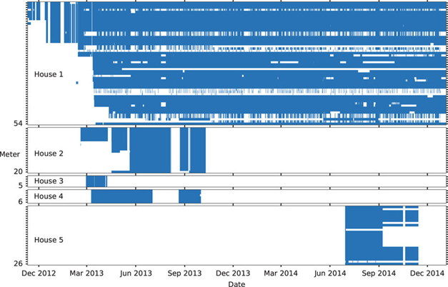
Fig. 2. Summary of The UK-DALE dataset
The main dataset contains five folder. Each folder correspond to each house. Under each house numbers of CSV files according to number of devices are given. Each CSV file contains records of power consumption with time. In each CSV file time is give in format of UNIX time epoch. Interval data recording is six seconds.
Noise and misleading data in any dataset are bad for any model to train on. A misleading dataset will eventually produce a hypothesis which will not do well in unseen data. Therefore noise cancellation has done with great care. The dataset contains UML configuration file for every houses. The file has details description of meter devices and appliances. Each appliance has upper bound and lower bound of power consumption. Any power consumption beyond that limit is considered as noise or bad reading. In Table 1 upper and lower bound of few devices recorded in house_1 is given.
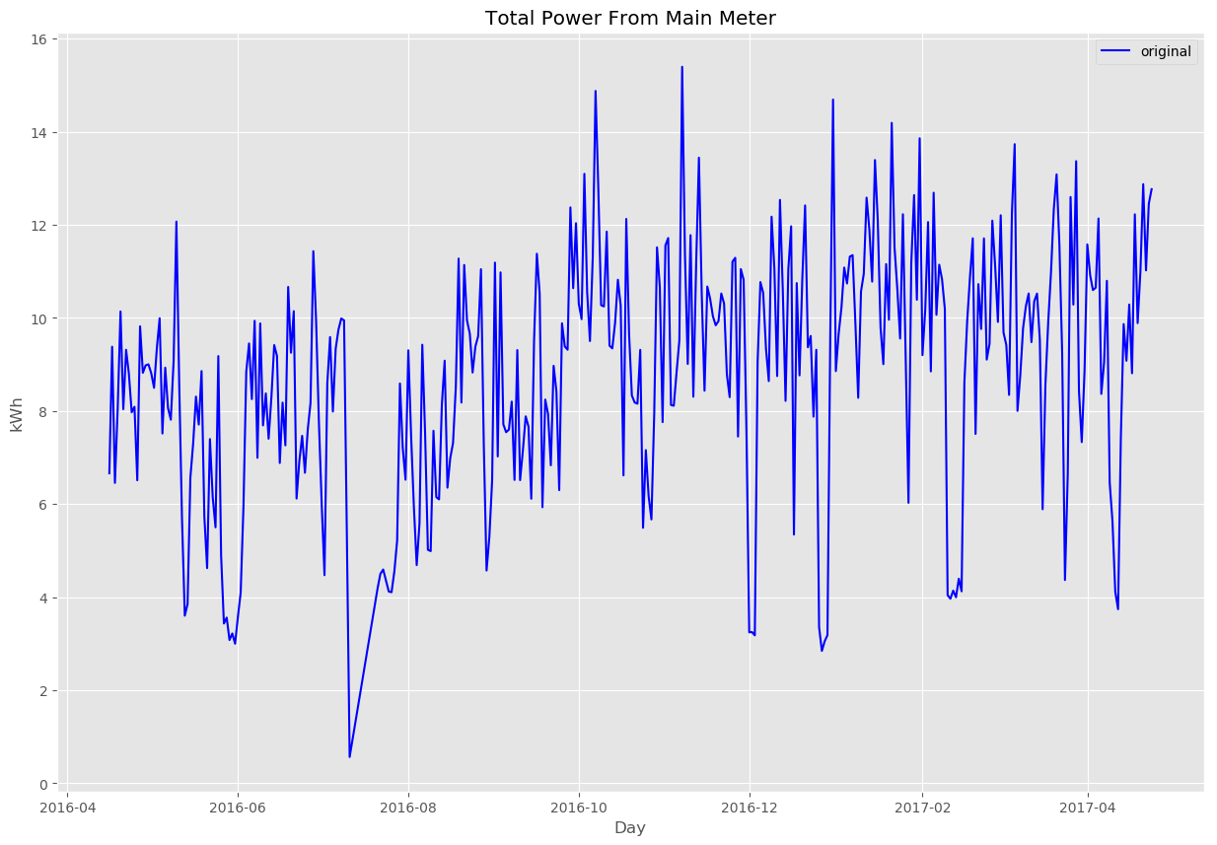
Fig. 3. Total Power Consumption of 1 year in KWh
- List of few devices
Channel ID | Name | Max Power (Watt) | Min Power (Watt) | Type
2 | boiler | 70 | 4000 | Apparent
3 | solar_thermal_pump | 43 | 4000 | Apparent
4 | laptop | 70 | 4000 | Active

The most frequently used measures of the differences between predicted values by an estimator and the actual values is the Root Mean Square Error (RMSE). The RMSE of predicted data for survey of , for variables is calculated for numbers of cases using the following formula:
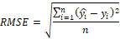
The parameters for building the predictive models of the algorithms are:
• Nearest Neighbors Regression: n_neighbors=15.
• Support Vector Regression: Penalty parameter C=1.0, epsilon=0.2 (specifies the epsilon-tube within which no penalty is associated in the training loss function with points predicted within a distance epsilon from the actual value).
• Decision Tree Regression with AdaBoost: max_depth=16, n_estimators=300.
• LSTM: the network contains on LSTM cell. Input of every time step contains a sequence of 10 sequential samples.
The algorithms Nearest Neighbors Regression, Support Vector Machine Regression, Decision Forest with AdaBoost is performed in using environment PyCharm IDE. Python v3.6.2 was used as coding language. The python library we used for building the above mentioned algorithms scikit-learn v0.19.1. It is an open source, commercially usable –BSD license. It has simple and efficient tools for data mining and data analysis.

Results
As our goal is to predict the power consumption of the house the next day depending on the power usage of the appliances of the present day. Model is evaluated on test set. The error result is obtained from test set. For preprocessing we scaled the data using the library function scale(). We used Kfold splits for splitting the dataset as it’s a time series dataset. Later we trained out model on train set and the error rate is acquired by evaluating the models against our test set. We used all the default settings of the library and few changes in parameters of few algorithms. We used an API out of 3 APIs of the library to measure our trained model’s performance. The API scoring parameter contains model-evaluating tools using cross-validation depends on an internal scoring strategy. We used this API to find the MSE of our models then used square root to find out RMSE and we compared the algorithms based on the result of the API.
Nearest Neighbors has RMSE of 1.9331727. As we are to predict the total power consumption of a house of the next day depending on the usage of the today’s power consumption of the appliances, for which we are getting this much higher RMSE value. In fig-4 the comparison of the real value and the predicted value of the trained model Nearest Neighbors Regression is given where x-axis is the date and y-axis is power consumption of the house in KWh.
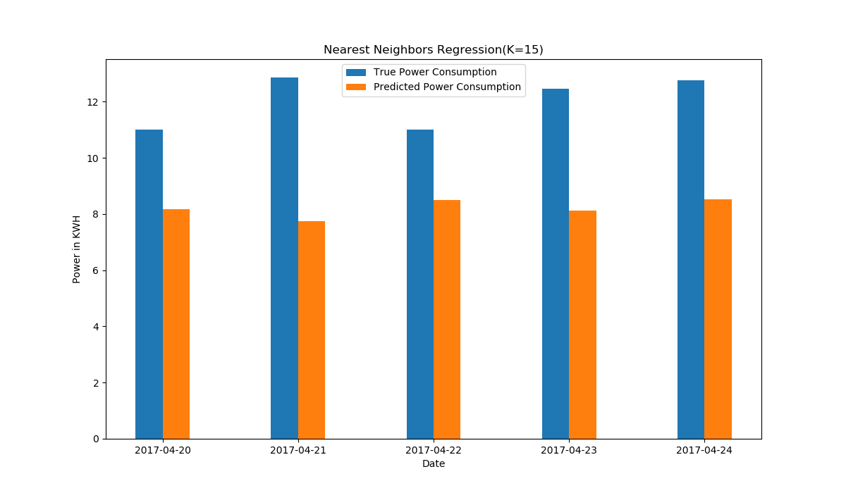
Fig. 1. Nearest Neighbors Regression, empirical comparison
Using the kernel RBF performs better than other kernels in SVR. RBF kernel performs better in this context because of the data. The higher the degree, the performance of other kernels are worse than RBF. SVR using kernel polynomial and Gaussian Radial Basis function with degree of 3 has RMSE of 2.1229618 and 1.8341087 respectively. But kernel linear performs slightly lesser than RBF but better than the polynomial as it has a degree of 1. It has RMSE of 1.8474361. For having the lowest RMSE among the kernel function, we preferred the kernel function RBF for SVR. In fig-5 the performance of Support Vector regression (kernel RBF) is shown by comparing the true value with predicted value where x-axis is date and y-axis is the power consumption of the appliances in KWh.
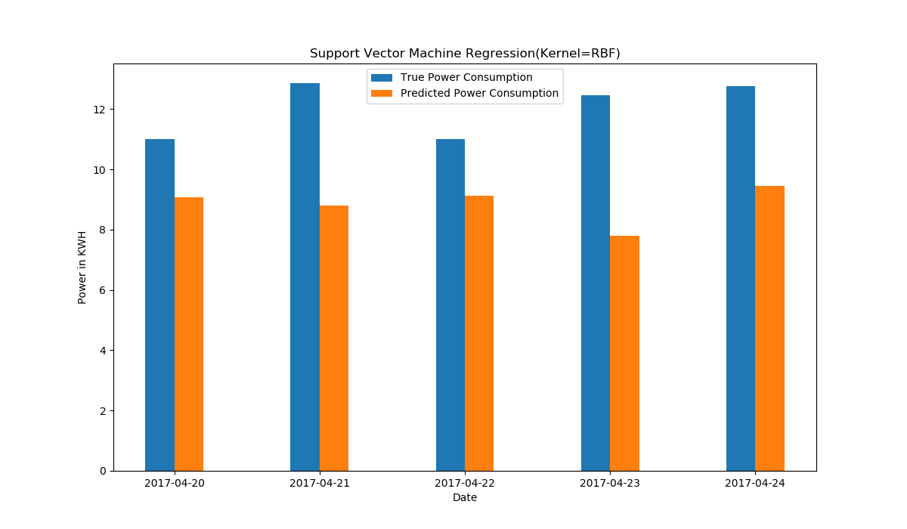
Fig. 2. Support Vector Regression, empirical comparison
The predicted power consumption is the output of the model. The RMSE of Decision Tree Regression with AdaBoost algorithm based model is 1.9202281. As we restricted the depth to 16 and we selected all the features to train the model we are getting much high RMSE. The deeper the tree is the model tend to over fit. To avoid overfitting we specified the maximum depth of the tree. In fig-6 Evaluation of the model Decision Forest Regression with AdaBoost is shown by comparing predicted and real value. In fig-6 x-axis is the date and y-axis is power consumption of the house in KWh.
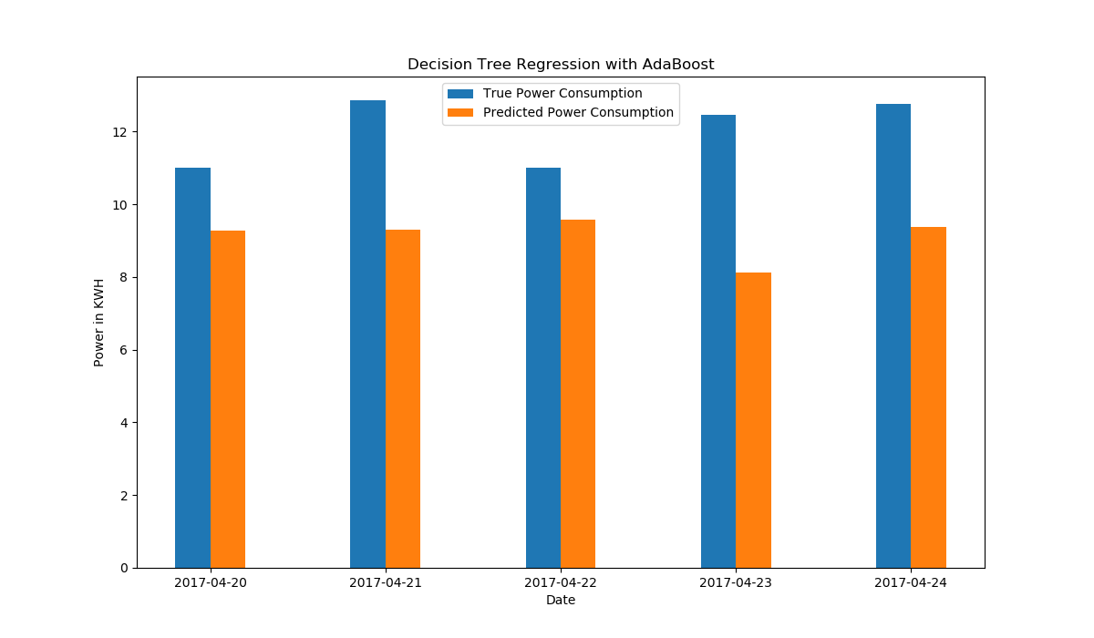Fig. 3. Decision Tree Regression with AdaBoost, empirical comparison
In experiment we used single cell LSTM network. We have tested with LSTM network with up to 3 LSTM cell stacked top of one another. Stacking more than one LSTM cell made computation heavier but did not give better result. In some cases it went bad. We have also experimented with length of look back. Here look back is how many samples is given as an input in each time step. We have tested variable length of look back. Most significant were 7 for 7 days, 15 for 15 days, 30 for 1 month. Length of look back (between 7 and 15), have given better result than longer look back like 30. We have found best result in look back length 10. In table -2 we can see LSTM has given lowest RMSE score. Reason of the lowest score is ability of a LSTM to process sequence of samples rather than a single sample. In Fig.7 we can see that predicted data points by a LSTM almost catches the pattern of electricity usages. In fig-8 point by point comparison of 10 test and predicted data point is given.
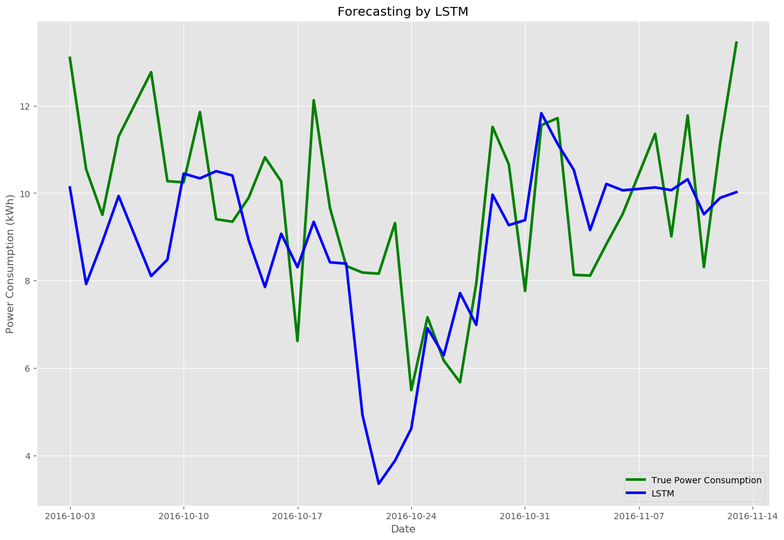Fig. 4. Load forecasting by LSTM
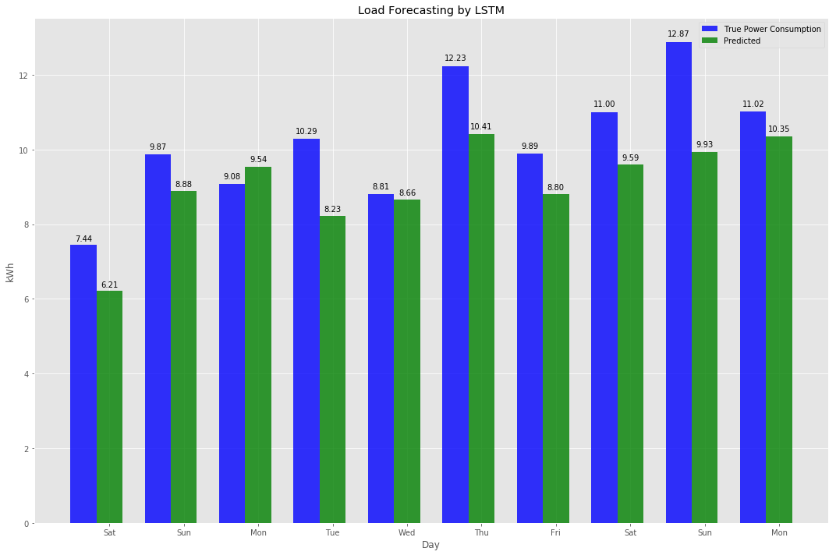Fig. 5. Load forecasting of LSTM, empirical comparison
- RMSE of ML models
Algorithms | Error
Algorithms | Root Mean Square Error
Nearest Neighbors Regression | 1.93
Support Vector Regression | 1.83
Decision Tree Regression with AdaBoost | 1.86
Long Short Term Memory | 1.65

In Fig.9 an overall summary of the outputs of four algorithm is given. Day by day our processors are getting stronger and less power hungry. Also in recent days processors are coming with dedicated core for neural net and artificial intelligence. As a result cost and computational power required for training a neural network will not be problem in the future. Neural networks like LSTM has the ability to adopt with a great variety of patterns and the ability of recognize those pattern. In our experiment LSTM has given better result with compared to Support Vector Machines Regression, Decision Forest Regression with AdaBoost and Nearest Neighbors Regression, Table-2.
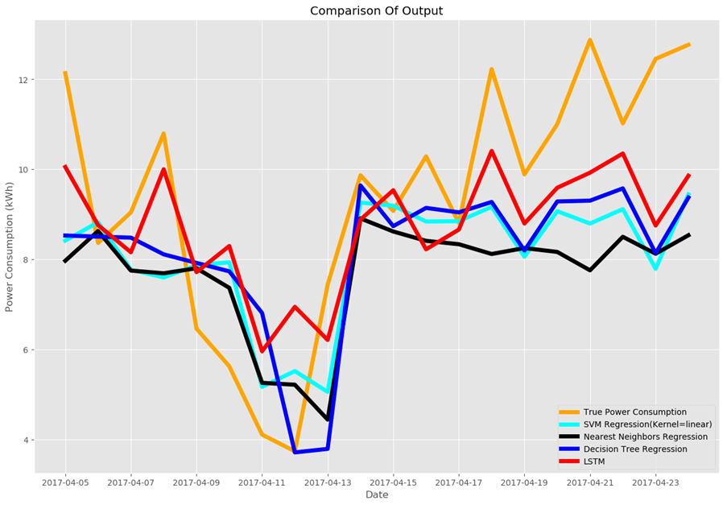
Fig. 9. Comparison of four ML Algorithms based on their outputs on same test set.

Conclusion
In this paper we have presented a system which can give prediction based on data collected from IoT devices. We have included weather data, holidays, weekends and power consumption of appliances. To prove the reliability of the system we have tested the system with real world data sets. We have conducted several experiments to evaluate the performance of four machine learning algorithms and concluded the experiment with a comparison of RMSE loss score. Long Short Term Memory network has given lowest RMSE in the experiment. The system described in this paper worked on data collected from IoT devices. Therefore privacy is a big concern here. In future we want to work on the security side of this system. We will try to improve the accuracy of prediction. This system can be used by home management and grid managements to save valuable resources.

References
The template will number citations consecutively within brackets [1]. The sentence punctuation follows the bracket [2]. Refer simply to the reference number, as in [3]—do not use “Ref. [3]” or “reference [3]” except at the beginning of a sentence: “Reference [3] was the first ...”
Number footnotes separately in superscripts. Place the actual footnote at the bottom of the column in which it was cited. Do not put footnotes in the reference list. Use letters for table footnotes.
Unless there are six authors or more give all authors’ names; do not use “et al.”. Papers that have not been published, even if they have been submitted for publication, should be cited as “unpublished” [4]. Papers that have been accepted for publication should be cited as “in press” [5]. Capitalize only the first word in a paper title, except for proper nouns and element symbols.
For papers published in translation journals, please give the English citation first, followed by the original foreign-language citation [6].

- G. Eason, B. Noble, and I.N. Sneddon, “On certain integrals of Lipschitz-Hankel type involving products of Bessel functions,” Phil. Trans. Roy. Soc. London, vol. A247, pp. 529-551, April 1955. (references)
- J. Clerk Maxwell, A Treatise on Electricity and Magnetism, 3rd ed., vol. 2. Oxford: Clarendon, 1892, pp.68-73.
- I.S. Jacobs and C.P. Bean, “Fine particles, thin films and exchange anisotropy,” in Magnetism, vol. III, G.T. Rado and H. Suhl, Eds. New York: Academic, 1963, pp. 271-350.
- K. Elissa, “Title of paper if known,” unpublished.
- R. Nicole, “Title of paper with only first word capitalized,” J. Name Stand. Abbrev., in press.
- Y. Yorozu, M. Hirano, K. Oka, and Y. Tagawa, “Electron spectroscopy studies on magneto-optical media and plastic substrate interface,” IEEE Transl. J. Magn. Japan, vol. 2, pp. 740-741, August 1987 [Digests 9th Annual Conf. Magnetics Japan, p. 301, 1982].
- M. Young, The Technical Writer’s Handbook. Mill Valley, CA: University Science, 1989.

